Functionality Requirements Document
- Document Control
Project Name: Manzil – Find more than a Destination
Version: v1.3
Prepared By: P. Kamal
Role: QA Tester
Date: 18 June, 2026
Reviewer: Suhel Shaik
Status: Pending
- Project Overview
Manzil is an AI Travel Planner which solves the chaotic and time-consuming process of travel planning by consolidating itinerary generation, budget allocation, weather forecasting, packing preparation, mapping, and expense tracking into a single and a cohesive experience. Traditionally, travellers must browse dozens of disconnected websites to schedule activities, estimate costs, check weather forecasts, list essentials to pack, and track their expenses. Manzil eliminates this friction by leveraging AI to generate highly personalized travel plans instantaneously, ensuring that trip preparation is stress-free, organized, and optimized.
The application is built for everyday travellers, vacationers, and budget-conscious explorers who seek customized travel plans without the hassle of manual scheduling. Users simply input their source, destination, travel dates, duration, budget, and personal interests. Manzil then generates a comprehensive day-by-day itinerary complete with hotel and restaurant suggestions, provides a visual budget breakdown, integrates live 7-day weather forecasts via the Open-Meteo API, offers a custom packing checklist, and includes an interactive expense log with real-time budget warnings. The final plans can be saved securely or exported as vector PDFs for offline access.

- Project Objectives
- Provides Highly Personalised Travel Planning
- Integrate Daily Route Mapping & Navigation
- Multiple Currency Support
- Streamline Budget Allocation & Expense Tracking
- Ensure High Availability and Offline Access
- Establish a premium user experience

- Scope
- User Authentication & Registration
- AI Powered Itinerary Generation with Customized Interests
- Daily Route Mapping
- Flexible Currency Customization
- Smart Budgeting & Expense Tracking
- Weather & Packing Checklist
- Saved Trips & PDF Exporting

- Functional Requirements
5.1 User Authentication Module
- FR-1.1 (Registration)
- FR-1.2 (Login & Sessions)
- FR-1.3 (Database Flexibility)
- FR-1.4 (Profile Querying)
5.2 Trip Generation and Itinerary Module
- FR-2.1 (Input Capture)
- FR-2.2 (AI Generation)
- FR-2.3 (Offline Itinerary Fallback)
- FR-2.4 (Day Regeneration)
5.3 Route Mapping Module
- FR-3.1 (Map Rendering)
- FR-3.2 (Daily Route Visualization)
5.4 Multi-Currency Module
- FR-4.1 (Currency Selection)
- FR-4.2 (Dynamic Conversion)
5.5 Budgeting & Expense Tracking Module
- FR-5.1 (Budget Optimization)
- FR-5.2 (Expense Logging)
- FR-5.3 (Budget Warnings)
- FR-5.4 (Expense Deletion)
5.6 Vault Storage & PDF Exporting Module
- FR-6.1 (Itinerary Vault)
- FR-6.2 (Vault Management)
- FR-6.3 (PDF Export)

6 Module-Wise Requirements
Module 1: Authentication
Features
- Registration
- Login
- Logout
Module 2: Dashboard
Features
- Itinerary Planning
- Itinerary Generation
- Interest Selection
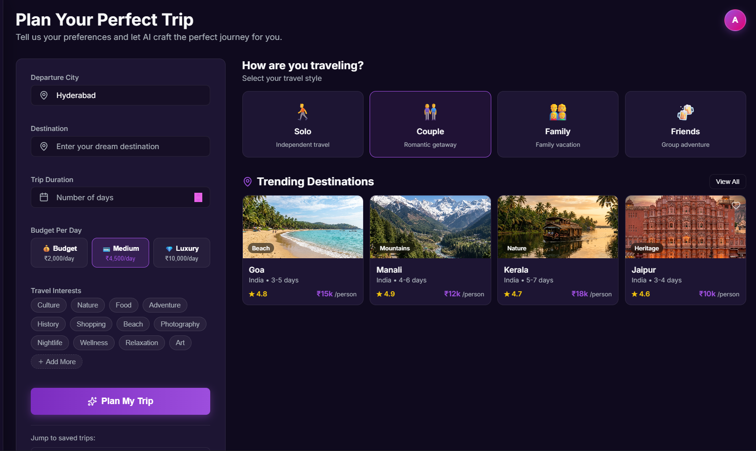Module 3: AI Engine
Features
- Prompt parsing & validation
- JSON response validation and robust fallback parsing
- Day-by-day Itinerary generation with coordinates, schedule, and estimated costs

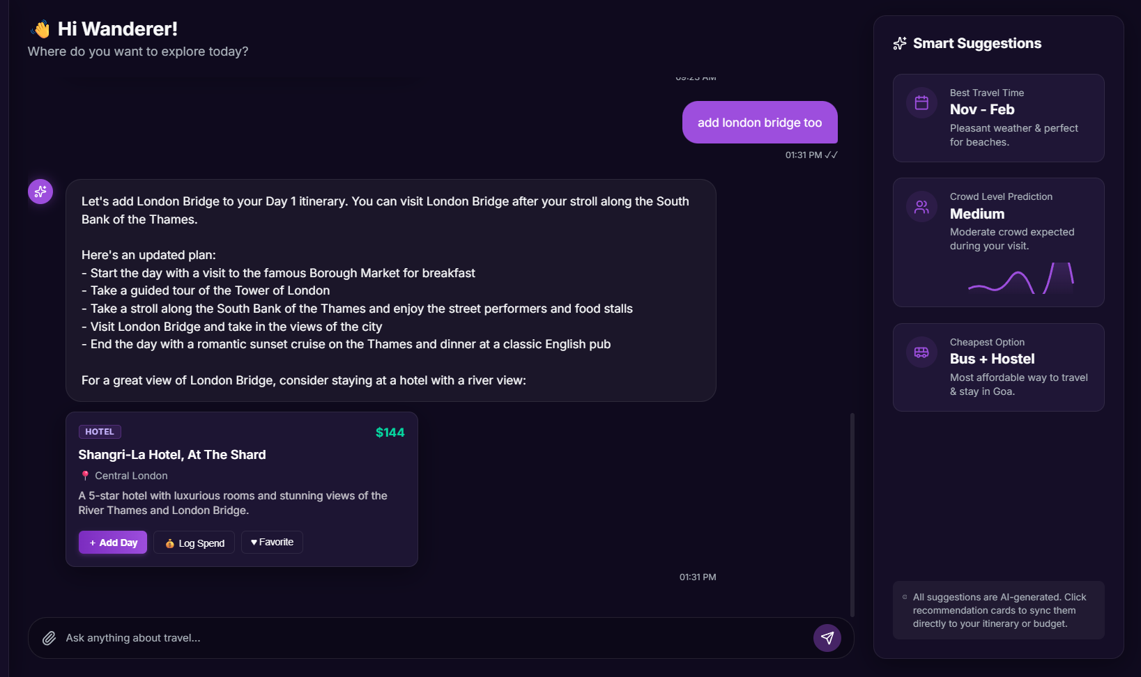Module 4: Route Mapping & Navigation

Features
Interactive Map Integration using Leaflet/React-Leaflet
Daily Route Visualization utilizing OSRM API for directions
Dynamic Waypoints mapping from AI-generated itinerary locations

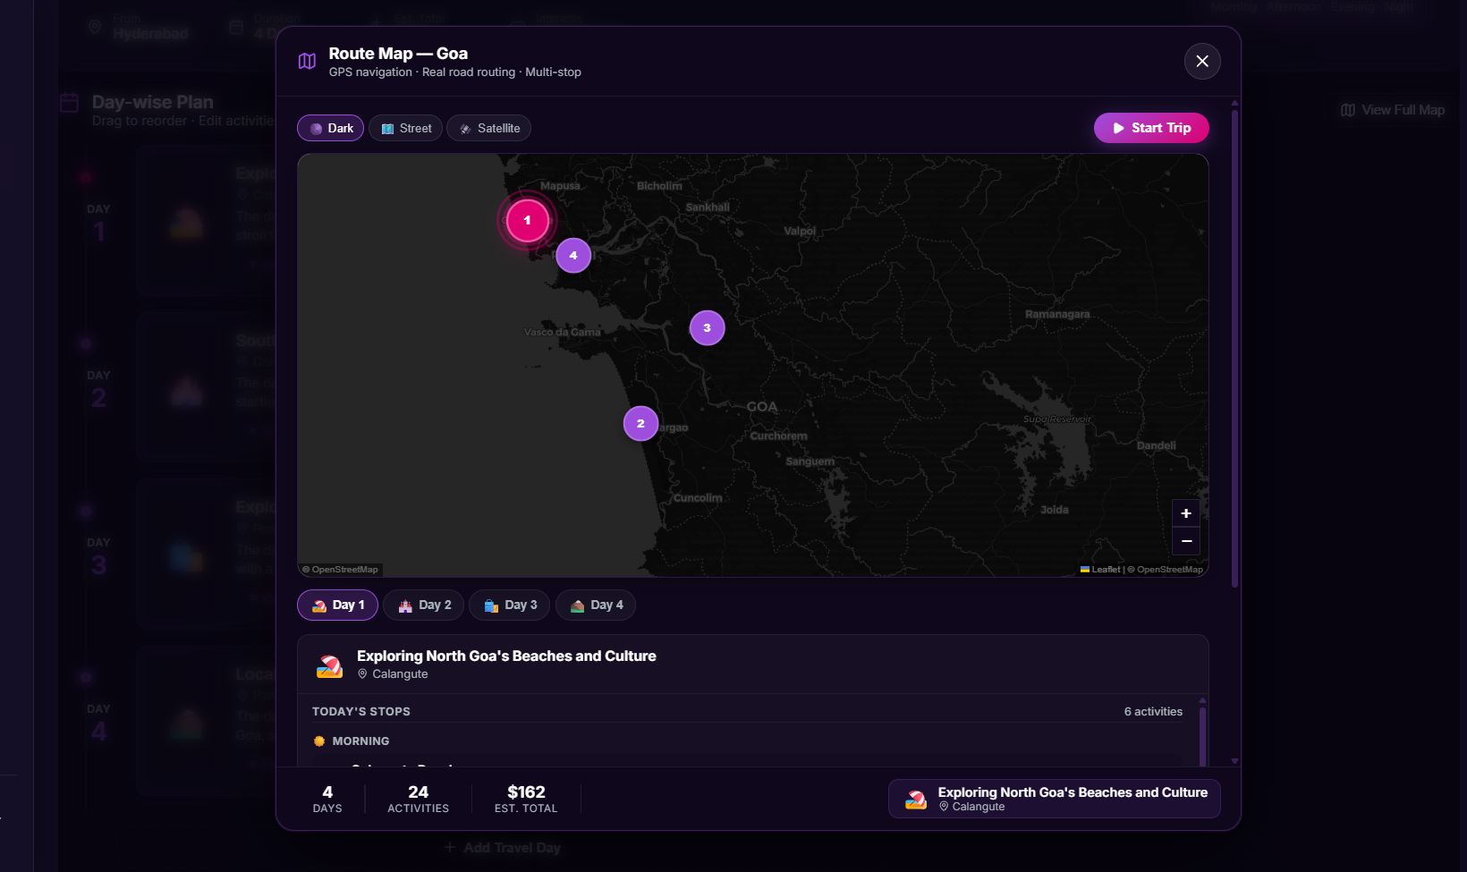Module 5: Financial Tracking

Features
Expense Logging (Category, Amount, Date, Description)
Real-time Budget vs Expense comparison with visual warnings
Multi-Currency conversion using real-time rates (INR, USD, EUR, etc.)

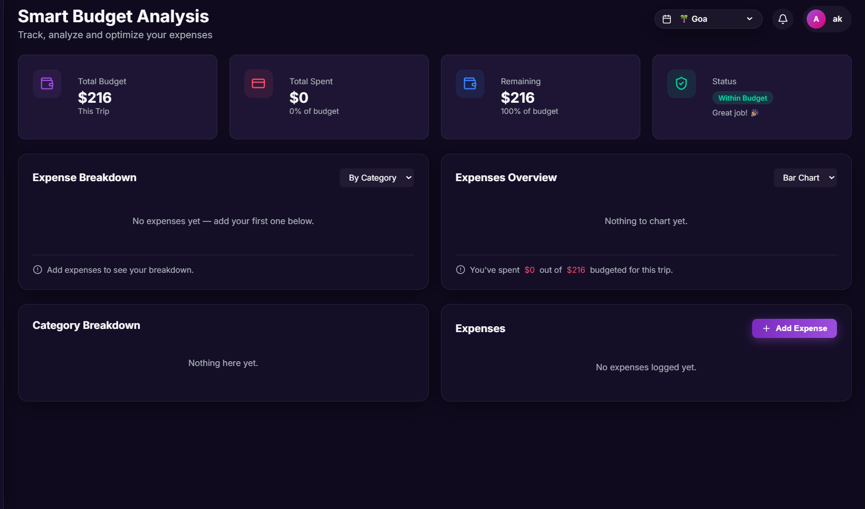Module 6: Saved Trips & Favorite Places

Features
Save generated itineraries securely to Supabase Database
Save Favorite Places (Hotels, Restaurants, Activities) from AI recommendations
View historical trips and favorites on Profile dashboard

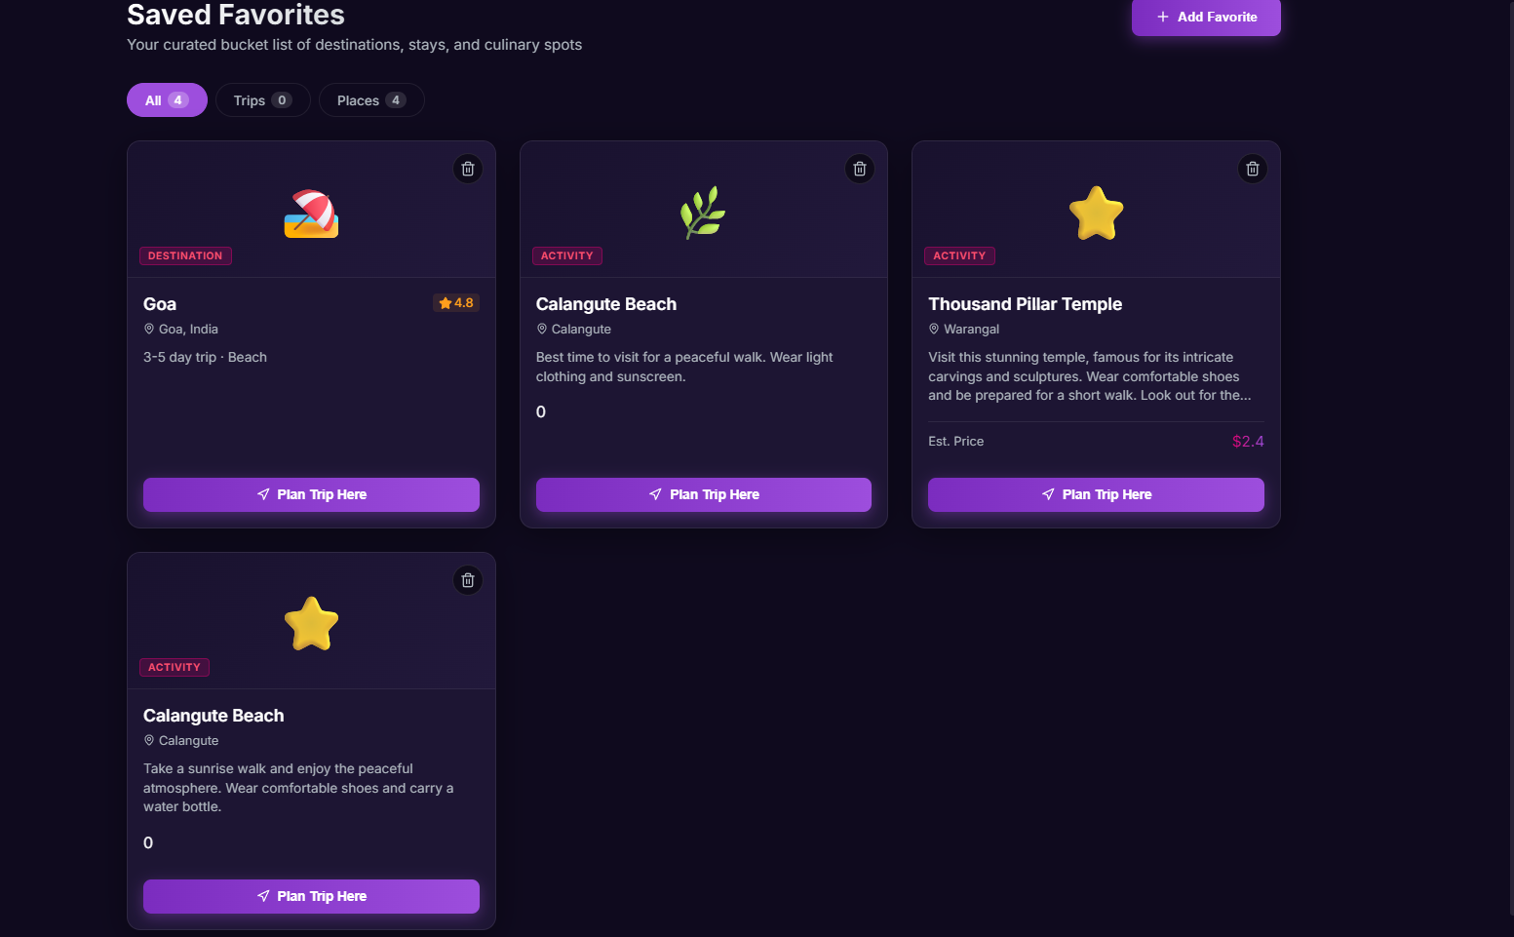Module 7: Offline & Export

Features
Export Itinerary to Vector PDF for offline usage
Weather 7-Day Forecast Integration (Open-Meteo)

